Whether the valuation of NEV is converging to mobile phone？

Contact us:

ibsghk@gmail.com

—— Next Step for NEV Valuation

Abstract:

* Comparing cars with phones, we could conclude that in the long run, services will converge, and charging channel fees for content will become mainstream
* As a valuation method, the sum of the part method becomes more valuable when analyzing the revenue of the single company
* Growth rate might have a significant difference between different company
* P/S multiple seems more suitable than the P/E ratio for new energy vehicle companies, and it will provide a more reasonable range to compare
* Intangible assets will account more significant part when conducting a valuation

**Content:**

Abstract: 1

Introduction: 3

1. Underlying value differences 3

1.1 Value of traditional fuel car 3

1.2. Value of new energy vehicles 3

2. Development trend of new energy vehicles 6

2.1. Electrification is the basis for the intellectualization 6

2.2. Pain points are gradually solved. Safety and miles traveled are no longer problems 6

2.2.1. Safety 6

2.2.2. Continuation 6

2.3 Shift from single vehicle charging to service charging, creating a sustainable profit model 8

2.3.1 Intelligence will be the core of the next stage 8

2.3.2 Compression of hardware profit space: hardware pre-embedding has become a trend, increasing the material cost of the vehicle 8

2.3.3 New Profit Margin: From New Car Sales to Holding Charges 9

2.3.4 Case study: Car vs. Phone 10

3. Conclusion 10

Introduction:

We have witnessed the rapid development of new energy vehicles in recent years. Still, the share prices of new energy vehicle companies have entered a volatile phase after the initial frenzy. We would like to qualitatively analyze the valuation of new energy vehicle companies by exploring the future development trend of new energy vehicles based on the bottom value of new energy vehicles and traditional fuel vehicles.

# 1. Underlying value differences

## 1.1 Value of traditional fuel car

Hardware-wise, the value of a fuel car is mainly determined by the "Three Major Components", which are the engine, transmission, and chassis. A fuel car's engine is generally the "heart" of the vehicle, and whether that car is good or not greatly depends on it.

According to German automotive economic expert Stefan Brazel, the engine accounts for an average of 15% of the cost of the car. Electronic systems and transmissions, and other configurations are related to the grade of the vehicle. Small car electronic systems are more straightforward and less expensive, accounting for about 20% of the cost of the car. In contrast, the electronic systems of luxury cars are advanced and complex, accounting for an average of 25% of the price of the vehicle.

Another aspect is the brand premium. The sentiment, the brand history, and public recognition determine the brand premium. For instance, Mercedes-Benz created enough compensation for its brand by being the brand synonymous with luxury and the world's first internal combustion engine car.

## 1.2. Value of new energy vehicles

For new energy vehicles, the value is mainly focused on two aspects. EIC System, including battery, electric transmission, electric control system; And on the other hand, the Intelligence, including intelligent cockpit, SaaS services, autonomous driving.

*Figure: New Energy Electric Vehicle Cost Estimate*

*Source: EV-costs-benefits-CN, International Council on Clean Transportation*

According to third-party cost calculations for new energy electric vehicles, it is expected that by 2025, the power battery system will account for about 30%-37.5% of the total cost of a single car. Other hardware components, such as the LCD instrument panel, head-up display (HUD), Etc., are essential to an intelligent cabin. At the same time, software components such as voice recognition, face recognition, touch control, gesture recognition, iris recognition, and other technologies supporting human-computer interaction are crucial. In addition, the software ecology has also generated a huge market, such as VW. OS, BYD DiLink, Azera NIO OS, Xiaopeng XmartOS, etc.

As presented by the market, the development path of "single-vehicle intelligence + network connectivity empowerment" is based on the "smart car" as the carrier, "smart road" as the support, and the "network link cloud control" to promote the implementation of advanced autonomous driving. Intelligent cars, also known as Autonomous vehicles (AV), are companies with intelligent roads, integrated information systems, communication technologies, and artificial intelligence (AI). Together, these two-part create an ecosystem for autonomous driving. This ecosystem can improve transportation efficiency and capacity significantly.

The value of autonomous driving has a huge potential, and it will catalyze a new service market in the foreseen future. The City of Tomorrow and Its Planning asserts that by 2050 we will need twice as much transportation as we do today and that this will only be possible with autonomous vehicles.

*Figure: Intelligent cockpit software and hardware platform introduction*

|  |  |  |  |
| --- | --- | --- | --- |
| **Brand** | **Type of Car** | **Cockpit Chip** | **Operation System** |
| NIO | NIO ES8 | Qualcomm Snapdragon 820A | NIO OS |
| NIO ES6 | Qualcomm Snapdragon 820A | NIO OS |
| NIO EC6 | Qualcomm Snapdragon SA8155P | NIO OS |
| NIO ET7 | Qualcomm Snapdragon SA8155P | NIO OS |
| Xpeng | P7 | Qualcomm Snapdragon 820A | Xmart Os |
| P5 | Qualcomm Snapdragon SA8155P | Xmart Os |
| G9 (XPILOT 4.0) | Qualcomm Snapdragon SA8155P | Xmart Os |
| G3i (XPILOT 3.5) | Qualcomm Snapdragon 820A | Xmart Os |
| Tesla | Model 3 | Intel A3950 | Version |
| Model Y | Intel A3950 | Version |
| LI Auto | ONE | Qualcomm Snapdragon 820A | Li OS |
| SAIC Motor | L7 | Qualcomm Snapdragon SA8155P | IMOS |
| BYD | Tang DM-i | Qualcomm Snapdragon 625 | DiLink |
| Han | Qualcomm Snapdragon 625 | DiLink |

*Source: Gasgoo, GGII, CICC Research Department*

# 2. Development trend of new energy vehicles

## 2.1. Electrification is the basis for the intellectualization

Increasing the car's electronic equipment is necessary for it to be intelligent. The power of traditional fuel cars relies on mechanical parts. Electric control for them is complex, and the battery capacity carried is limited, therefore, traditional fuel cars are a bit forced to realize intelligence.

Electric cars, by contrast, have a more straightforward mechanical structure, more accurate control, and faster feedback. It can be powered directly from the battery, which means that intelligence has to be built around electrification. In addition, there is static electric balance, which means that when the vehicle is not in use, sitting for a while can still ensure the expected start of the car. For intelligent devices containing electronic instruments, static balancing in fuel cars is almost impossible, while in new energy vehicles, only a 40Ah battery is enough**.**

## 2.2. Pain points are gradually solved. Safety and miles traveled are no longer problems

### 2.2.1. Safety

In recent years, power batteries have had some problems such as being overcharged, external short circuits, extrusion, drop, etc.; Failure reactions include light leakage, fire, explosion, and other issues. But at present, safety is no longer a problem.

(1) On the demand side, battery safety has become a new round of car companies' focal point in addition to the range and fast charging point of publicity.

(2) On the supply side, to seize market share, the development of high-safety batteries has become the industry consensus.

(3) On the policy side, upgrading national safety standards tightens industry regulations. Therefore, considering that the improvement for power batteries includes the intrinsic safety at the cell level, passive safety, and active safety at the battery system level, car companies must meet the specifications with the advancement of safety requirements.

### 2.2.2. Continuation

CTL's public information indicates that the third generation CTP (Cell to Pack) technology (the Kirin battery) is known for its extreme charging speed, low energy consumption, and high safety.

*Figure: Basic Data of the Kirin Battery*

|  |  |  |
| --- | --- | --- |
|  | **Lithium Iron Phosphate System** | **Ternary System** |
| Energy Density | 160 Wh/kg, 290 Wh/L | 250 Wh/kg, 450 Wh/L |
| Range (Expected) | 1000 km | 1000 km |

*Source: CTL’s Public Data*

Another competitor is Tesla's 4680. As its name implies, this is a single cylindrical cell measuring 46mm in diameter and 80mm in height. This simplified structure can also improve the charging speed of the battery, meanwhile reducing the overall weight and improving the energy density. According to the 4680’s technical specifications, the energy density has increased by five times to 300 kWh/kg, the range of the car using 4680 has increased by 16%, the output power has increased by 6%, and the cost has decreased by 14%.

*Figure: Stacking Up the Benefits of Tesla’s Vertical Integration*

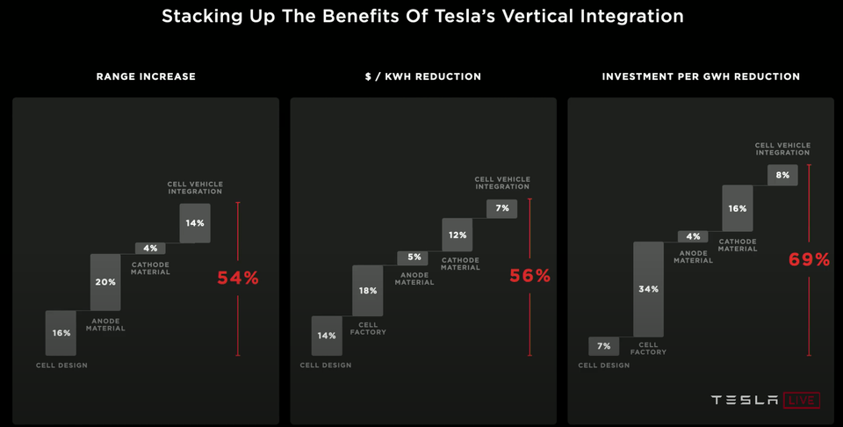

*Source: Tesla’s News Conference*

## 2.3 Shift from single vehicle charging to service charging, creating a sustainable profit model

### 2.3.1 Intelligence will be the core of the next stage

In the past, in the fuel car stage, the car's software system was merely an accessory, and the computer onboard mainly supported safety-assisted driving and in-car entertainment. Everything in today's electric car stage moves towards intelligence, from the autonomous driving system to the intelligent cockpit, to vehicle-road communication. Taking Baidu, as a leader in autonomous driving, as an example, Baidu is now involved in the comprehensive commercialization of autonomous driving layouts, from self-driving unmanned robotics to autonomous driving technology ANP \ AVP to other intelligent driving products.

Traditionally, car companies have relied on new car sales for profits. Still, suppose services with high customer stickiness are charged by use or duration. In that case, it changes the industry's revenue structure from relying on new car sales for profits to set up a more extensive scale ownership market. Tesla, Azera, and Xiaopeng are examples of companies that have tried autonomous driving.

For example, Tesla invested nearly $7 billion in research and development in the past five years, assuming ten years as the complete cycle of autonomous driving. If Tesla's investment-related to autonomous driving reaches Rmb50 billion, then high-level autonomous driving can charge $10,000 or Rmb64,000. At 40% penetration, a new car can contribute close to Rmb10,000 of profit per vehicle, which has outstripped most of the whole-car enterprise hardware profit; at 60% penetration, a new vehicle can contribute close to Rmb28,000. This shows that the charging model of car companies has shifted from the original profitability of selling new vehicles to the medium-term reliance on differentiated hardware-based software charges (autonomous driving).

### 2.3.2 Compression of hardware profit space: hardware pre-embedding has become a trend, increasing the material cost of the vehicle

Driven by leading companies such as Tesla, car companies have realized the importance of software and service charges. Through hardware pre-embedding, they have improved the car's perception, computing, and execution capabilities, although short-term software is not enough to improve hardware performance. Fully developed, but automakers expect to delay such revenue through OTA remote upgrades. The investment of lidar, a large number of high-definition cameras, and high computing power chips have increased the material cost of the vehicle.

*Figure: GAC BOM cost list*

|  |  |  |
| --- | --- | --- |
| Hardware Type | Price (¥ RMB) | Propertion (%) |
| Interior and exterior | 40,296 | 13% |
| Body + Chassis | 43,880 | 15% |
| EIC System | 132,048 | 44% |
| Intelligent Network | 41,028 | 14% |
| Total Material Costs | 257,252 | 86% |
| Total Costs | 300,022 | 100% |

*Source: Company reports, CICC Research Department*

### 2.3.3 New Profit Margin: From New Car Sales to Holding Charges

For a long time, the auto industry has relied on the manufacture and sales of new cars for profit. However, if some services with high customer stickiness are charged by use or by term, it will change the industry's revenue structure from relying on new car sales for-profit to a larger scale—market charges for penetration.

The in-vehicle software charging is highly exclusive, resulting in low customer acquisition (CAC), high user retention, and high customer lifetime value (LTV). If we introduce the concept of user lifetime value to examine the profit of in-vehicle software, in-vehicle hardware-based software services (such as ADAS autonomous driving functions) have the characteristics of being combined with hardware, so they are highly exclusive: the customer acquisition process is The vehicle procurement process has been completed, and the follow-up customer acquisition cost is lower, which only depends on the value-added of the in-vehicle software itself to consumers, so the customer acquisition cost CAC is low. In addition, the average service life of vehicles is as high as about ten years, so once customers start to stickiness to in-vehicle software, the consumption cycle is longer, so the lifetime value (LTV) from users is longer.

### 2.3.4 Case study: Car vs. Phone

Apple relies on ecology rather than its software to make profits, and the value of content is higher than the hardware itself. In the case of Apple, it does not generate profits from its onboard software (free for camera, photography, maps, music software, electronic wallet, and other functions), instead of charging "channel fees" (music purchases in iTunes, software purchases in AppStore). This reflects that when services converge (many mobile phone brands can implement the above functions), they will eventually tend to be free, which is quite similar to the recent charging capabilities of autonomous driving software. The output value of the mobile phone industry is about $450 billion in 2020, and the market value of mobile Internet companies is nearly $6 trillion. In general, the value of content is higher than the hardware itself. In the process of realizing autonomous driving, the attention of drivers and passengers has gradually shifted from inside the car to outside the car, which has also brought about a shift in the value chain. Companies that provide in-vehicle entertainment, consumption, and content are more valuable among them.

# 3. Conclusion

In simple terms, new energy vehicles are no longer just cars. It’s similar to the iPhone (and a traditional fuel car for Blackberry), adding intelligence and services while retaining the original essential functions. As the value point of the new energy vehicle ecosystem shifts from the engine to the power battery and intelligence, in the foreseeable future, in-vehicle services will be the most essential and valuable element of this ecosystem, with a $100 billion market size.

It seems that new energy vehicles are about to step into the stage of intelligence. With the trend of hardware pre-embedding, the profit margin for hardware is narrowing, but it enlarges room for charging for service. The in-vehicle software charging is highly exclusive, with lower CAC, high user stickiness, and LTV, and the massive scale of penetration market makes it the primary source of profit for NEV manufacturers.